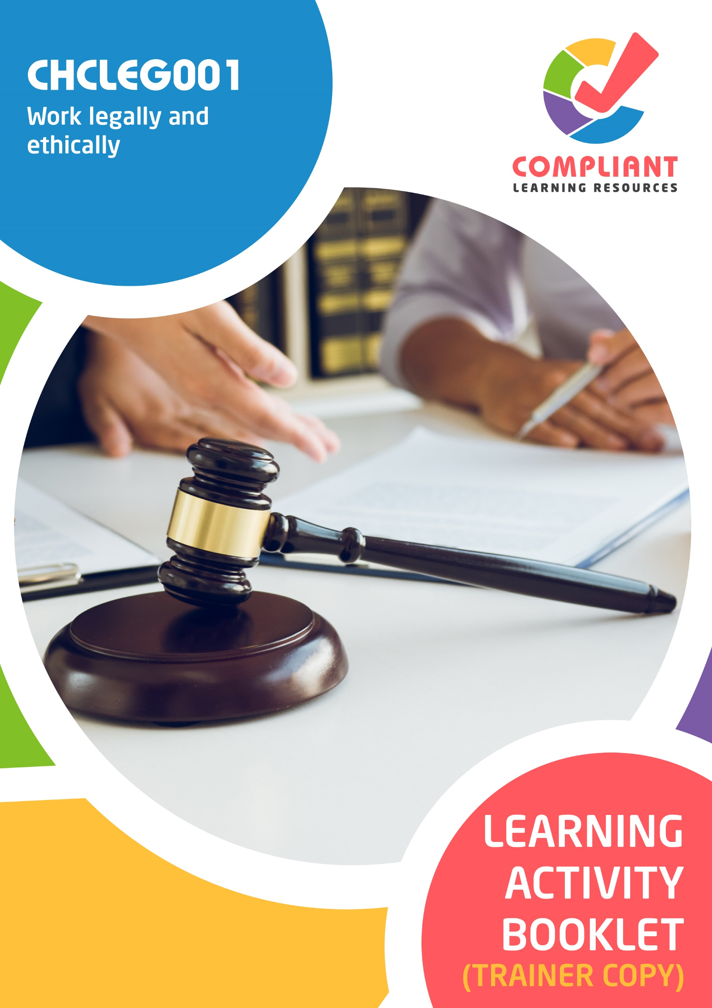

**Copyright**

This document was developed by Compliant Learning Resources.

© 2022 Compliant Learning Resources.

All rights reserved.

No part of this publication may be reproduced, stored in a retrieval system, or transmitted in any form or by any means, electronic, mechanical, photocopying, recording, or otherwise without the prior written permission of Compliant Learning Resources.

**Version Control & Document History**

|  |  |  |
| --- | --- | --- |
| **Date** | **Summary of Modifications** | **Version** |
| 13 May 2022 | Version 1.0 released for publishing | 1.0 |

# Table of Contents

Overview 4

Trainer Instructions 5

Learner Instructions 6

Learner Information 6

Trainer Information 6

Resources Required 7

Work Health and Safety 7

Reasonable Adjustment 8

Contextualisation 9

Formative Activities 10

I. Identify and Respond to Legal Requirements 10

Activity 1.1 10

Activity 1.2 11

Activity 1.3 12

II. Identify and Meet Ethical Responsibilities 13

Activity 2.1 13

Activity 2.2 14

III. Contribute to Workplace Improvements 15

Activity 3.1 15

Activity 3.2 16

Activity 3.3 17

# Overview

**CHCLEG001 - Work legally and ethically (Release 1)**

This unit describes the skills and knowledge required to identify and work within the legal and ethical frameworks that apply to an individual job role.

This unit applies to community services and health workers who play a proactive role in identifying and meeting their legal and ethical responsibilities.

**A complete copy of the above unit of competency can be downloaded from the TGA website:**

[https://training.gov.au/training/details/CHCLEG001](https://training.gov.au/training/details/chcleg001)

# Trainer Instructions

This Learning Activity Booklet contains formative activities that learners will complete in the classroom or a similar environment.

These formative activities include knowledge questions to test learners’ underpinning generic knowledge and practical activities to test their skills relevant to the unit/s of competency.

These formative assessments are used by trainers to complement both the learning and training processes, and to evaluate how learners are progressing throughout these processes.

**IMPORTANT:**

**The completion of the formative assessments and learning activities included in this workbook DOES NOT lead to a Qualification or a Statement of Attainment (SOA).**

Reasonable adjustment applies here, and while the majority of learners will complete this assessment as a written assessment, verbal assessment may be an option for those who need it. The assessor must use the marking guide as the principal marking tool unless a reasonable adjustment is demonstrated.

The Learning Activity Booklet (Trainer Copy) provides model answers to all the questions, setting out which key responses must be included as well as indicating where flexibility is acceptable.

The number of responses required is specified in each assessment task to avoid ambiguity. In these cases, the model answer will provide a list of possible answers. For instance, if a question requires the learner to list three examples, then their response must include three of the items listed in the model answer.

# Learner Instructions

This Learning Activity Booklet contains formative activities that learners will complete in the classroom or a similar environment.

These formative activities include knowledge questions to test your underpinning generic knowledge and practical activities to test your skills relevant to the unit/s of competency.

These formative assessments are used by your trainer to complement both the learning and training processes, and to evaluate how you are progressing throughout these processes.

You may reference your Learner Guide and other learning materials to complete the activities included in this workbook.

**IMPORTANT:**

**The completion of the formative assessments and learning activities included in this workbook DOES NOT lead to a Qualification or a Statement of Attainment (SOA).**

## Learner Information

|  |  |
| --- | --- |
| Learner name |  |
| Phone |  |
| Email |  |

## Trainer Information

|  |  |
| --- | --- |
| Trainer name |  |
| RTO name |  |
| RTO phone |  |
| RTO email |  |

# Resources Required

Resources needed to complete activities included in this workbook include:

* Computer with Internet, email access, and a working web browser
* Installed software: MS Word, Adobe Acrobat Reader
* Learner guide
* A volunteer to participate in a role play activity

# Work Health and Safety

Both the trainers and learners have duty of care in ensuring that the learning environment is free from hazards that may pose risks to their health and safety.

According to WHS legislation, trainers and learners must take reasonable care while undertaking the activities included in this workbook in the learning environment.

# Reasonable Adjustment

‘Reasonable adjustment’ in VET is the term applied to modifying the learning environment or making changes to the training delivered to assist a learner with a disability. A reasonable adjustment can be as simple as changing classrooms to be closer to amenities or installing a particular type of software on a computer for a person with vision impairment.

**Why make a reasonable adjustment?**

We make reasonable adjustments in VET to make sure that learners with disabilities have:

* The same learning opportunities as learners without disabilities, and
* The same opportunity to perform and complete assessments as those without disabilities.

**Reasonable adjustment applied to participation in teaching, learning, and assessment activities can include:**

* Customising resources and assessment activities within the training package or accredited course
* Modifying the presentation medium
* Learner support
* Use of assistive/adaptive technologies
* Making information accessible both before enrolment and during the course
* Monitoring the adjustments to ensure learner needs continue to be met

**Assistive/Adaptive Technologies**

Assistive/adaptive technology means ‘software or hardware that has been specifically designed to assist people with disabilities in carrying out daily activities’ (World Wide Web Consortium - W3C). It includes screen readers, magnifiers, voice recognition software, alternative keyboards, devices for grasping, visual alert systems, and digital note-takers.

*(Adapted Reasonable Adjustment in teaching, learning and assessment for learners with a disability - November 2010 - Prepared by - Queensland VET Development Centre)*

**IMPORTANT:**

**Reasonable adjustment made for collecting learner assessment evidence must not impact the standard expected by the workplace, as expressed by the relevant unit/s of competency. For example, if the assessment were gathering evidence of the learner’s competency in writing, allowing the learner to complete the assessment verbally would not be a valid assessment method. The method of assessment used by any reasonable adjustment must still meet the competency requirements.**

# Contextualisation

Contextualisation is the process of modifying assessment tools to make learning more meaningful for your students and their employers.

Compliant Learning Resources highly recommends that your RTO contextualise the assessment tools before using them.

You must contextualise the assessment tools to suit:

* Your student’s needs
* Your RTO’s training and assessment processes
* The work and industry context in which you operate

**Contextualising for your state/territory**

The contents of this assessment tool are not written for a specific state/territory unless stated otherwise. Where the assessment tool refers to legislation and other industry requirements, which may vary across states/territories, model answers are based on one state/territory.

Should your RTO intend to use this assessment tool for learners from your state/territory, Compliant Learning Resources recommends you to:

* Access and review the legislation and industry requirements applicable in your state/territory.
* Update assessments and benchmark answers to reflect the legislation and industry requirements applicable in your state/territory.

When you are contextualising assessment tools, you must ensure that you retain the integrity of the assessment and the outcomes of the unit of competency.

**A comprehensive guide to contextualising your assessment tools for your RTO can be accessed through this link:**

<https://compliantlearningresources.com.au/blog/simple-guide-to-contextualising-rto-training-resources-and-assessment-tools/>

# Formative Activities

## I. Identify and Respond to Legal Requirements

### Activity 1.1

|  |  |  |  |  |  |  |  |
| --- | --- | --- | --- | --- | --- | --- | --- |
| **Matching Type**  Identify the common terms used in legislation being described in each statement below.   |  | | --- | | **Common Terms Used in Legislation** | | Act | | Amendment | | Bill | | Commencement | | Preamble | | |
|  | |
| *Mapping: CHCLEG001 PC1.1 (p)*  *Learner guide reference: CHCLEG001 Learner Guide, Chapter 1, Subchapter 1.1, Section 1.1.3* | |
| Description | |
| Preamble | 1. It sets out the reasons for and scope of a law. |
| Amendment | 1. It is a change to the law generally made by another law. |
| Commencement | 1. It is the time/date at which a law comes into force. |
| Bill | 1. It is a draft Act of Parliament. |
| Act | 1. It is a statute or law passed by both Houses of Parliament that has received Royal Assent. |

### Activity 1.2

|  |
| --- |
| **Fill in the blanks**  The following are statements about ways of responding to legal issues. Review each and complete the statement by filling in the missing words/phrases. |
|  |
| *Mapping: CHCLEG001 KE3.2 (p)*  *Learner guide reference: CHCLEG001 Learner Guide, Chapter 1, Subchapter 1.4, Section 1.4.2* |
| 1. When you consult a       lawyer, they can give you legal counsel and the proper approach to sort out an issue. |
| 1. Mediation is a similar process to negotiation but a neutral person, called the       mediator, is involved. The neutral person should not be biased towards any people involved. Their role is to guide parties in reaching an agreement |
| 1. Arbitration is a process where the neutral person, called the       arbitrator, makes a decision. The neutral person listens to both parties and decides how to resolve the issue. Both parties should comply with the neutral person’s decision. |
| 1. You can resolve legal issues through       alternative dispute resolution, such as negotiation and mediation. |
| 1. Litigation is a process of taking the legal issue to court. At the end of this process, a judge will make a decision on how the issue should be resolved. |

### Activity 1.3

|  |
| --- |
| **SCENARIO**  The first responder answered an emergency call. It was from a mother. She said that her child fainted.  When the responder arrived at the scene, he evaluated the situation. There were no hazards that posed risks to anyone in the area. He assessed the unconscious child. The child needed cardiopulmonary resuscitation (CPR).  Before the treatment, the first responder asked for the mother’s consent. He explained the procedure and the need for it. The mother understood and gave him her consent. He then proceeded to do CPR. |

|  |
| --- |
| What legal requirement did the first responder adhere to in the scenario? |
|  |
| *Mapping: CHCLEG001 PC1.3 (p)*  *Learner guide reference: CHCLEG001 Learner Guide, Chapter 1, Subchapter 1.3*  **Marking guide**  The learner must identify the legal requirement the first responder adhered to in the scenario.  For a satisfactory performance, although the wording may slightly vary, their response must be consistent with the benchmark answer below. The underlined words/phrases must appear in the learner’s response. |
| The first responder adhered to the legal requirement of obtaining consent before doing any procedure to the casualty. |

## II. Identify and Meet Ethical Responsibilities

### Activity 2.1

|  |  |
| --- | --- |
| **Matching Type**  Listed below are ethical issues occurring in the workplace.   1. Discrimination 2. Harassment 3. Conflict of interest 4. Neglect 5. Breach of privacy and confidentiality.   Match each to their description below, by writing the letter that corresponds to your answer in the space provided. | |
|  | |
| *Mapping: CHCLEG001 KE4.1 (p)*  *Learner guide reference: CHCLEG001 Learner Guide, Chapter 2, Subchapter 2.4, Section 2.4.1* | |
| Description | |
| a | 1. It means giving unfair treatment to people due to their identity or characteristics. |
| c | 1. This instance occurs when someone’s personal interests may affect their ethical judgment. |
| d | 1. It refers to the failure to care for a person adequately. |
| e | 1. This instance occurs when personal information are accessed by other unauthorised people. |
| b | 1. It involves unwanted actions that offend, intimidate, or humiliate another person. |

### Activity 2.2

|  |
| --- |
| List five sources of ethical responsibilities in the workplace. |
|  |
| *Mapping: CHCLEG001 PC2.1 (p)*  *Learner guide reference: CHCLEG001 Learner Guide, Chapter 2, Subchapter 2.1*  **Marking guide**  The learner must list five sources of ethical responsibilities in the workplace,  For a satisfactory performance, although the wording may slightly vary, their response must include five of the following.   * code of conduct * codes of practice * practice standards * guidelines * policies * procedures * protocols   Other answers are acceptable as long as they are documents containing ethical responsibilities in the workplace. |
|  |
|  |
|  |
|  |
|  |

## III. Contribute to Workplace Improvements

### Activity 3.1

|  |
| --- |
| **Fill in the blanks**  The following are statements related to meeting legal and ethical responsibilities. Review each and complete the statement by filling in the missing words/phrases. |
|  |
| *Mapping: CHCLEG001 PC3.1 (p)*  *Learner guide reference: CHCLEG001 Learner Guide, Chapter 3, Subchapter 3.1* |
| 1. Legal responsibilities are anchored in the existing laws. |
| 1. Universal moral values guide       ethical responsibilities. |
| 1. You can       evaluate work practices by observing how policies are implemented in the workplace. |
| 1. You can       ask questions to determine your colleagues’ stand on company policies and procedures. |
| 1. You can obtain       feedback from the client to help improve work practices and to better meet legal and ethical responsibilities. |

### Activity 3.2

|  |  |
| --- | --- |
| **True or False**  Review the statements below about developing policies and protocols. Indicate whether each statement is True or False.  Tick the box that corresponds to your answer. | |
|  | |
| *Mapping: CHCLEG001 PC3.3 (p)*  *Learner guide reference: CHCLEG001 Learner Guide, Chapter 3, Subchapter 3.3* | |
| TRUE  FALSE | 1. The first step in developing policies and protocols is to identify the need for one. |
| TRUE  FALSE | 1. Research is not a part of the development process for policies and protocols. |
| TRUE  FALSE | 1. Stakeholders should be consulted during the development of policies and protocols. |
| TRUE  FALSE | 1. There is no need to make a draft when developing policies and protocols. |
| TRUE  FALSE | 1. The goal of developing policies and protocols is to implement them in the workplace. |

### Activity 3.3

|  |
| --- |
| **SCENARIO**  You received feedback from a parent regarding the safety of the school’s playground. You know that sharing the feedback to your colleagues will help the school improve its policies and practice. You decided to set up a meeting with your supervisor to discuss the feedback you received. |

|  |
| --- |
| **Role Play Activity**  Role play the scenario with a volunteer to discuss the feedback about the safety of the school’s playground, while demonstrating the practical skills listed in the checklist below.  Perform this activity while being observed by your trainer. If your trainer is not available to directly observe you, you may video record the role play activity and submit the recording to your trainer.  **Your role**  For this activity, you will take the role of the education support worker.  **The volunteer’s role**  For this activity, the volunteer will take the role of the supervisor. |

|  |  |  |
| --- | --- | --- |
| *Mapping: CHCLEG001 PC3.2 (p)*  *Learner guide reference: CHCLEG001 Learner Guide, Chapter 3, Subchapter 3.2*  **Marking guide**  The learner must role play the scenario provided above while demonstrating the practical skills listed below and while being observed by the trainer. The trainer must use the checklist below to evaluate the learner’s performance during the activity. | | |
| **Role Play Checklist** (For trainer’s use only) | | |
| **During the role play activity:** | **YES** | **NO** |
| 1. The learner verbally relays the feedback to the supervisor. |  |  |
| 1. The learner discusses how the feedback affects the clients (students and parents). |  |  |
| 1. The learner discusses how the feeback affects the employees. |  |  |
| 1. The learner discusses how the feedback affects the organisation (school). |  |  |
| 1. The learner suggests on what can be done about the feedback. |  |  |
| Trainer’s overall feedback on the learner’s performance during the role play activity: | | |

End of Document